# [**Chris Meloni’s ‘Law & Order: SVU’ Spinoff Delayed at NBC Amid Showrunner Change (Exclusive)**](https://www.hollywoodreporter.com/tv/tv-news/chris-melonis-law-order-svu-spinoff-delayed-at-nbc-amid-showrunner-change-exclusive-4070280/#!)

Chris Meloni's 'Law & Order: SVU' Spinoff Delayed at NBC Amid Showrunner Change (Exclusive)

**BY** [**LESLEY GOLDBERG**](https://www.hollywoodreporter.com/author/lesley-goldberg/)

OCTOBER 2, 2020 9:00AM

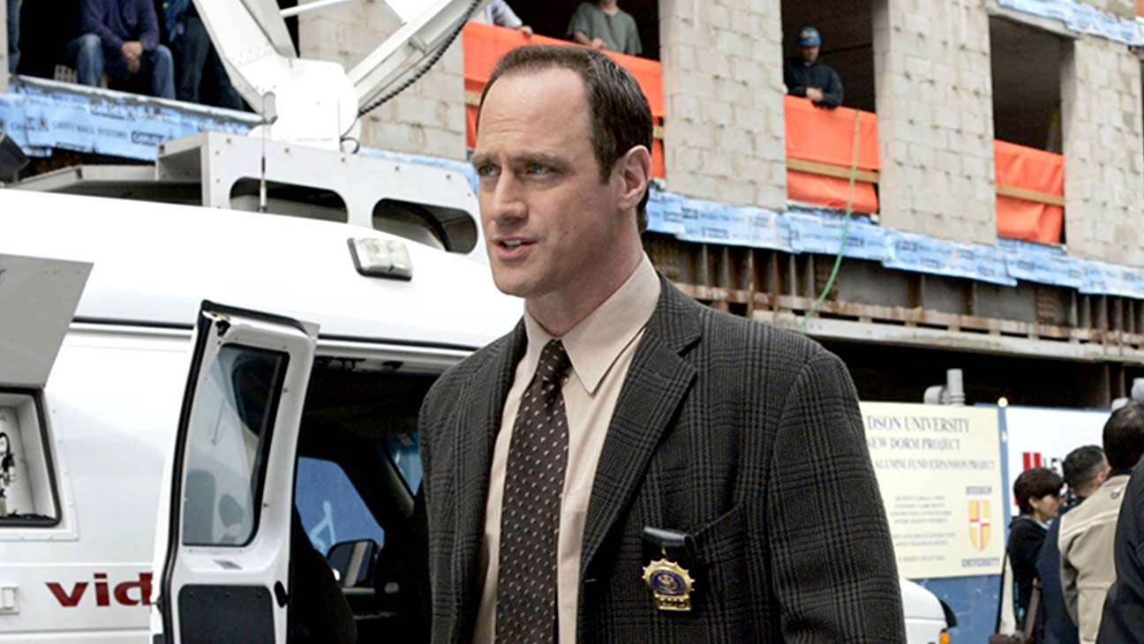

NBC/PHOTOFEST

[Logo text](https://www.hollywoodreporter.com/e/live-feed/)

Elliot Stabler’s return will have to wait.

*Law & Order: Organized Crime,* the *SVU* [spinoff](https://www.hollywoodreporter.com/live-feed/nbc-plots-business-as-usual-fall-schedule-1298689) set to feature Chris Meloni’s long-awaited return to the [Dick Wolf](https://www.hollywoodreporter.com/t/dick-wolf/) franchise, is changing showrunners and has been delayed from [NBC](https://www.hollywoodreporter.com/t/nbc/)’s anticipated “fall” schedule.

Sources say showrunner Matt Olmstead is exiting the straight-to-series drama amid challenges cracking the show’s creative. Olmstead, who quietly signed a lucrative three-year overall deal to return to his former home with Universal TV, is expected to land at another Wolf-produced show. Olmstead previously had a four-year stint with Wolf Entertainment, where he helped launch and eventually served as showrunner on *Chicago Fire,* co-created and ran *Chicago P.D.* and helped develop *Chicago Med* as well as oversaw multiple crossover episodes of the *Chicago* universe. He departed in May 2017 and signed a [two-year, eight-figure overall deal](https://www.hollywoodreporter.com/live-feed/chicago-pd-showrunner-moves-abc-studios-rich-deal-999212) with ABC Studios where he helped launch last season’s *Stumptown*. (The latter series changed showrunners after Olmstead departed amid a creative shift before it was surprisingly canceled last month.)

### **Related Stories**

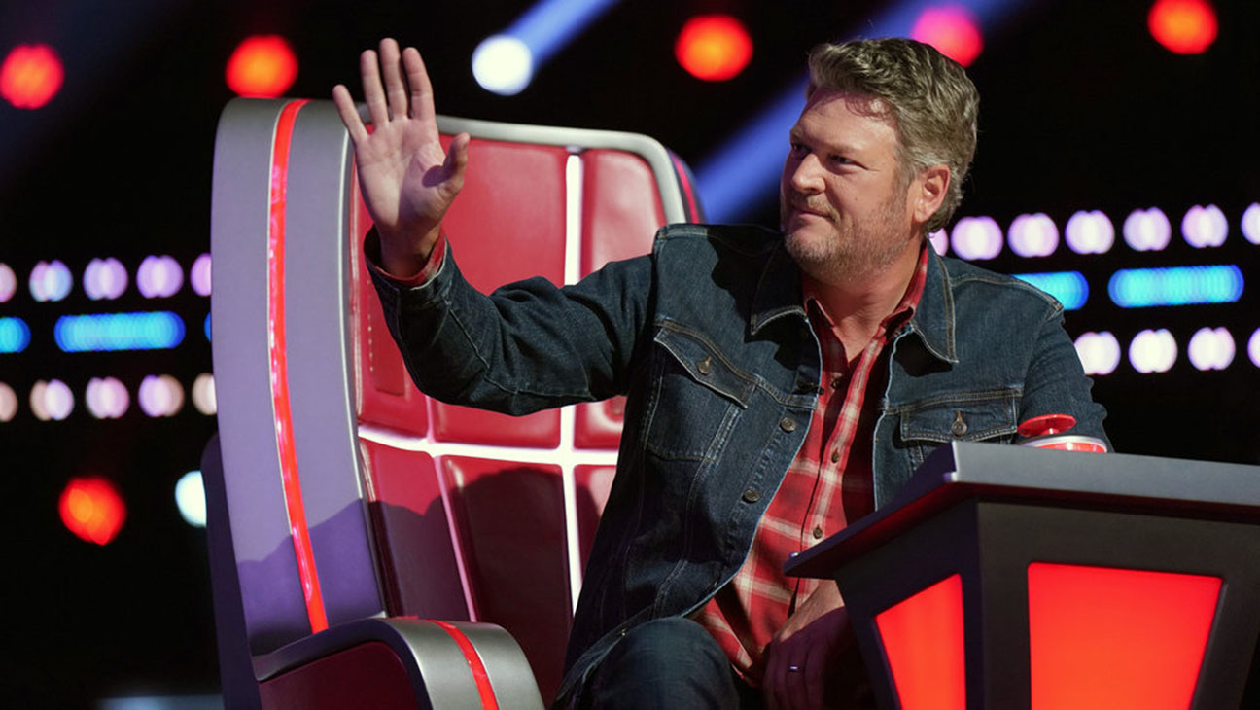

[**TV**](https://www.hollywoodreporter.com/c/tv/)

### [Blake Shelton to Exit 'The Voice' With Season 23](https://www.hollywoodreporter.com/tv/tv-news/blake-shelton-leave-the-voice-season-23-1235239520/)



[**TV**](https://www.hollywoodreporter.com/c/tv/)

### [NBC Orders 'America's Got Talent: All-Stars' Spinoff](https://www.hollywoodreporter.com/tv/tv-news/americas-got-talent-all-stars-spin-off-1235235786/)

As for *L&O: Organized Crime,* the Meloni-led spinoff was picked up straight to series back in March with a 13-episode order. Wolf executive produces alongside Arthur W. Forney, Peter Jankowski, Fred Berner and Terry Miller. In June, NBC announced that the show would take over the prized Thursdays at 10 p.m. slot on its [“fall” schedule](https://www.hollywoodreporter.com/live-feed/nbc-plots-business-as-usual-fall-schedule-1298689). A return date had yet to be announced given the challenges associated with production during the pandemic. NBC’s lone scheduled scripted drama remains *This Is Us* as the network, like others, has set a staggered premieres based on when production can resume.

Sources note that *L&O: Organized Crime* is still slated to air sometime during the 2020-21 broadcast season, though it’s unclear when. The new season officially got under way late last month as an increasing number of scripted dramas and comedies have returned to production and are beginning to roll out in the coming weeks. The Meloni series had yet to begin production or reveal its full cast.

*L&O: Organized Crime* brings Meloni back to the Wolf and *L&O* fold after he departed *SVU* following season 12. The show joins the long-gestating *Law & Order: Hate Crimes* in limbo for Wolf and company. That show was ordered straight-to-series with a 13-episode pickup in September 2018 and was [delayed](https://www.hollywoodreporter.com/live-feed/law-order-svu-spinoff-hate-crimes-delayed-at-nbc-1192215) the following March. Warren Leight, who captains *SVU* and serves as showrunner on *Hate Crimes,* previously told *THR’*s [*TV’s Top 5 podcast*](https://podcasts.apple.com/us/podcast/tvs-top-5/id1438063915?i=1000476891676) in June that it’s likely to wind up at NBCUniversal-owned streamer Peacock at some point, though there has not been any official comment on the show’s status.